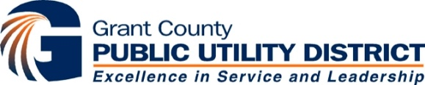

December 31, 2019

RE: $75,045,000*
Public Utility District No. 2 of Grant County, Washington
Electric System Revenue Refunding Bonds, Series 2020-Q (Taxable)

Public Utility District No. 2 of Grant County, Washington (the “District”) plans to issue $75,045,000* of its Electric System Revenue Refunding Bonds, Series 2020-Q (Taxable) (the “Bonds”) and to apply the proceeds, with other available funds of the District and depending on market conditions, to defease and refund certain outstanding bonds of the District’s Electric System for debt service savings and to pay costs of issuing the Bonds.
Simultaneously with the issuance of the Bonds and subject to market conditions, the District expects to issue $127,400,000* of its Priest Rapids Hydroelectric Project Revenue Refunding Bonds, 2020 Series Z (Taxable) and to apply the proceeds, with other available funds of the District, to defease and refund certain outstanding bonds of the Priest Rapids Project for debt service savings and to pay costs of issuing such bonds.
Both transactions are expected to price the week of January 6, 2020 through negotiated sale and close on or around January 29, 2020.
In connection with the sale of the Bonds, KeyBanc Capital Markets Inc. (the “Representative”), on its own behalf and on behalf of J.P. Morgan Securities LLC (“Senior Co-Manager”) and Citigroup Global Markets Inc. and RBC Capital Markets LLC (the “Co-Managers,” and together with the Representative and the Senior Co-Manager, the “Underwriters”) will serve as Underwriters for the Bonds.
Although the District plans to move forward with the transactions described above, the District reserves the right to change or modify its plans as necessary.

_________________
* Preliminary, subject to change.

