New User Activation

Before using myHR for the first time, you must activate your account.

Navigate to <https://gcpud.ultipro.com>

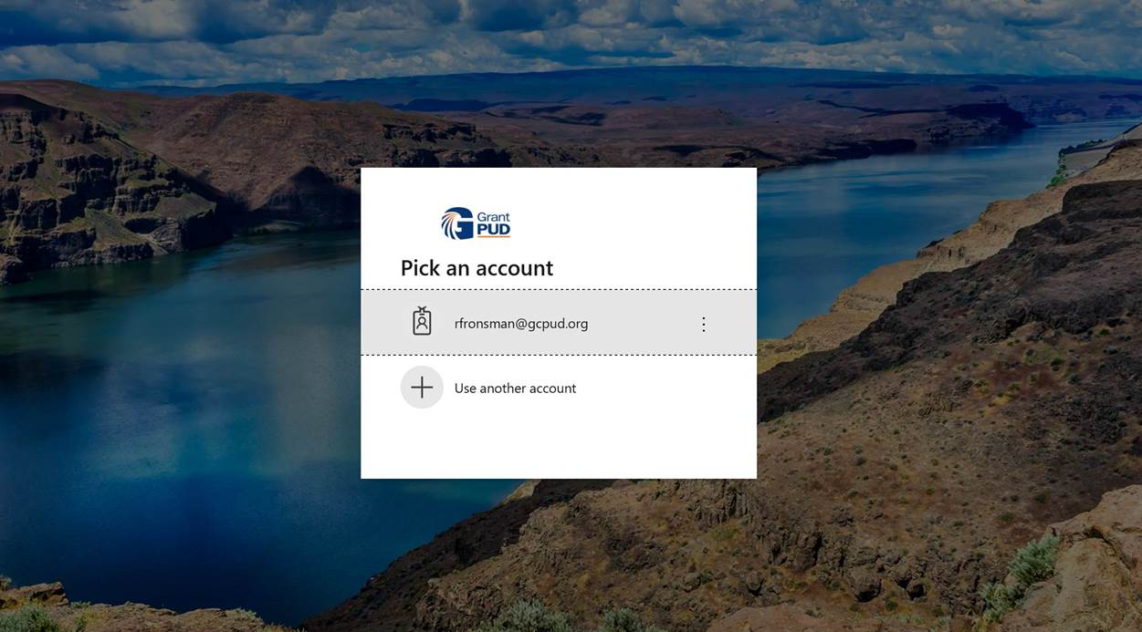

You will be redirected to a new browser window to complete the New Activation form.

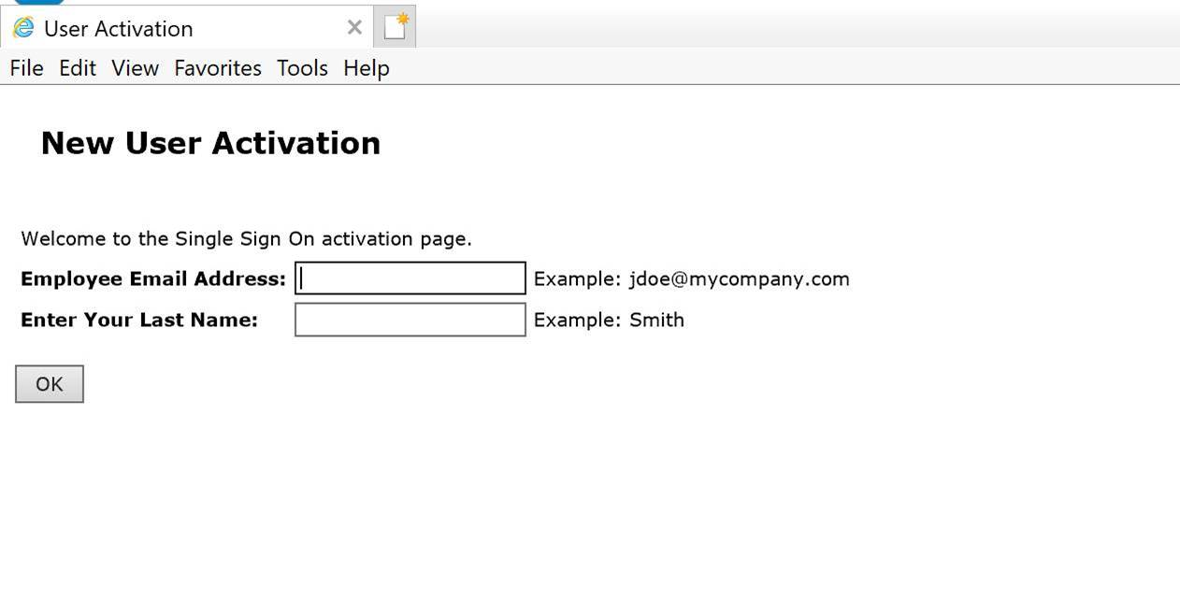

After entering your PUD email address and last name, the system will send you an email with a link.

Click the link in your email.

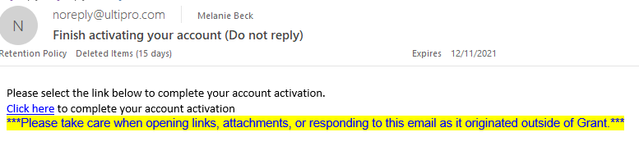

You will be redirected to a windows asking you how you want to receive your temporary access code.

Choose your preferred delivery method and press the Submit button when complete.

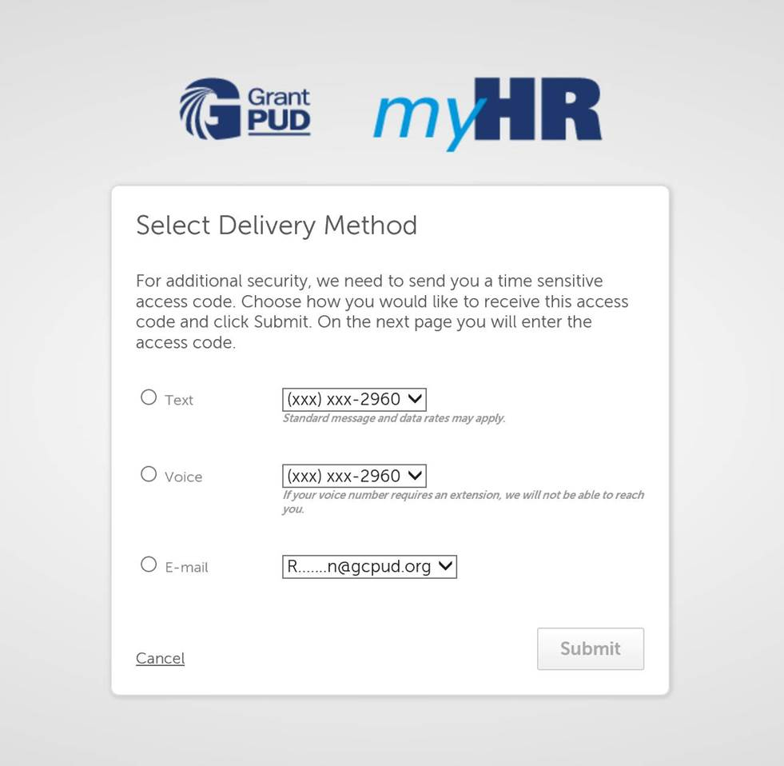

In the sample below, the code was sent via email.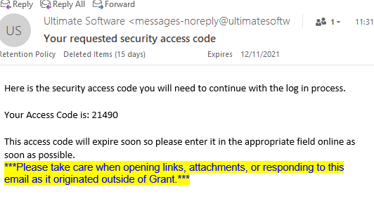

Return to the myHR browser widow and enter your access code. You will have 5 minutes to enter the code before it expires.

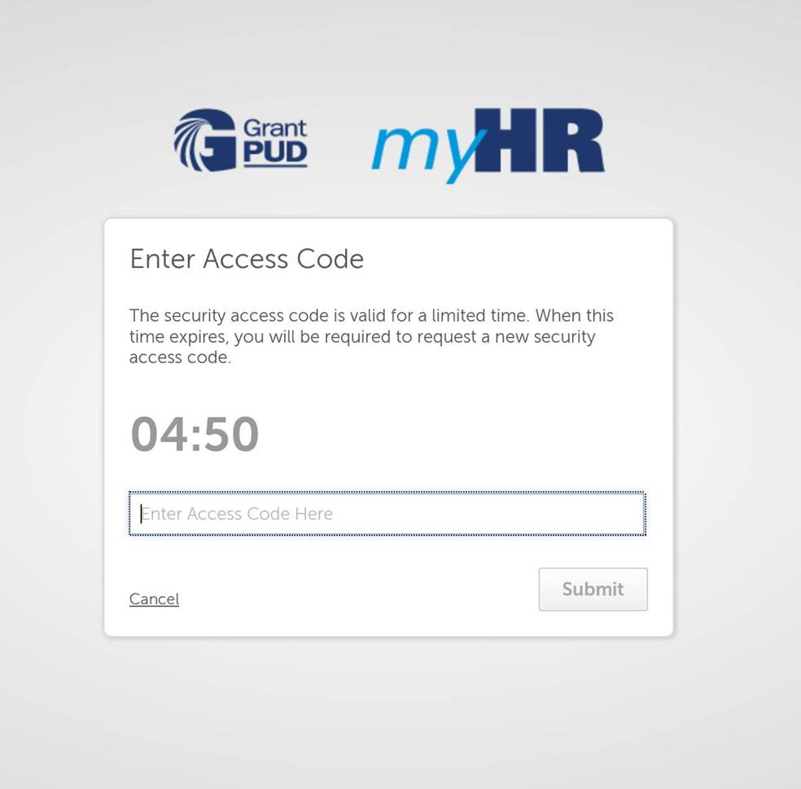

21490

You will be redirected to a window where you create your account password. UltiPro assigns a default Current Password, which is your birthdate.

Enter your Current Password (your birthdate), using the format MMDDYYYY.

Enter a New **local** UltiPro Password (*this does* ***NOT*** *affect your GPCUD password*).

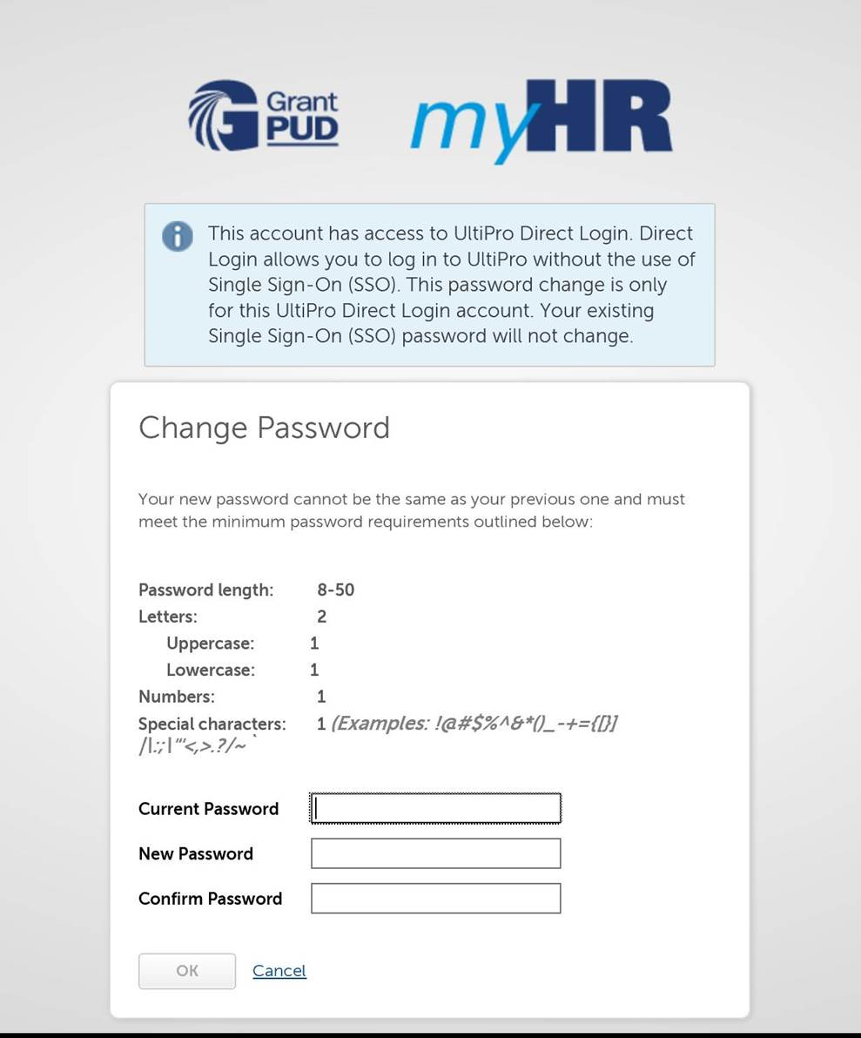

MMDDYYYY

Once logged in locally, close the browser. You can now logon using your PUD email address. If you are asked for your password, use your PUD network password.

