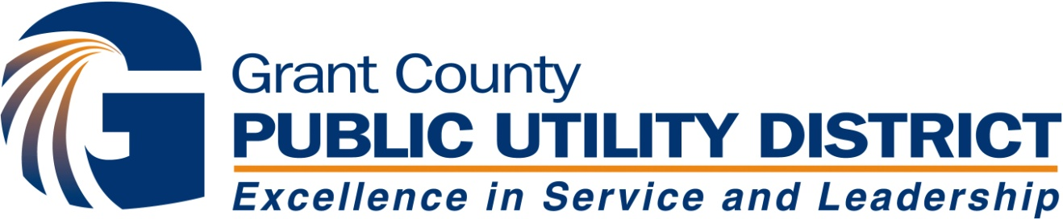

Priest Rapids Coordinating Committee
MEETING
Wednesday, January 25, 2017
Wanapum Dam HOB 107

PRCC Representatives
Scott Carlon, Justin Yeager (Alt), NMFS Jim Craig, USFWS
Bob Rose, YN Kirk Truscott, Casey Baldwin (alt), CCT
Jeff Korth, C. Andonaegui (Alt), P. Verhey (Alt) WDFW Tom Skiles, CTUIR
Curt Dotson, Tom Dresser (Alt), GCPUD Erin McIntyre, GCPUD
Denny Rohr, D. Rohr & Assoc, Facilitator

Meeting Agenda
- Welcome and Introductions
- Agenda Review (D. Rohr)
- Meeting Minutes Approval: (D. Rohr)
  - Request for approval of October 12, 2016 conference call; November 16, 2016 meeting; December 7, 2016 conference call; December 13-14 meetings
- Action Items Review from December 13-14, 2016 meeting (D. Rohr)

- 2016 Avian Predation Presentation – Allen Evans, Real Time Research; Dan Roby, OSU (C. Dotson)
  - UPDATE -- Draft 2016 Avian Report
  - ACTION ITEM: Request for NNI Funding

- 2016 Survival Study Report – “Survival of Acoustic Tagged Steelhead Smolts through the Priest Rapids Project in 2016” – (C. Dotson)
  - Skalski Report – Comment Period Closed
  - Blue Leaf Report – Begin 30 Day Comment Period

- Discussion: Sub-yearling and NNI Funding Calculations (All)

- ACTION ITEM: SOA 2016-05, Schedule for Conducting Sub-Yearling Summer Chinook Survival Evaluations (C. Dotson, D. Rohr)
- NNI Funding Proposal – “Factors Influencing the Survival of Juvenile Spring Chinook Salmon in Lake Wenatchee, WA” (J. Korth)
- Grant PUD Coho Mitigation (T. Dresser, C. Dotson)
- ACTION ITEM: SOA 2017-01, Designation of Coho Salmon Survival Surrogate (C. Dotson)

- Presentation of NNI Funding Proposal – “Feasibility of Collecting Adult Spring Chinook Salmon Using a Fish Wheel or Trap in the Estuary and Lower Columbia River, Michelle Rub/NOAA; Leah Sullivan/Blue Leaf Environmental
- Quincy Valley Chamber of Commerce / Tourism Association -- 2017 Northern Pikeminnow Fishing Derby (T. Dresser)
- Potpourri: “The Blob” Presentation/Schedule – (B. Rose)
- Updates
- Avian Predation Activities (C. Dotson)
- Hatchery Activities (T. Dresser)
- Carlton Acclimation Facility
- Nason Creek Acclimation Facility
- Priest Rapids Hatchery Modifications
- Penticton Hatchery
- Hatchery Permits: Sec 10 Consultation/Summer Chinook, Sec 7 Consultation/Bull Trout. (T. Dresser)
- Review of NNI Funded Projects
- 2016 Real Time Research / Oregon State university – “Evaluation of Caspian Tern Management to Reduce Predation on ESA-Listed Salmonids in the Columbia Plateau Region” - (C. Dotson)
- Upper Columbia Fish Screen Monitoring Program Phase I - II Contract Extension – (J. Korth)
- Mid-Columbia River Intake Screen and Diversion Assessment (2016-17) – (T. Dresser)
- Lower Wenatchee Instream Flow Enhancement Project Phase II – (J. Korth)
- Methow Valley Irrigation District (MVID) Instream Flow Improvement Project (T. Dresser)
- Predator Fish Recruitment Reduction (Report in Spring, 2017) (B. Rose)
- Committee Reports (D. Rohr)
- Qtrly NNI and Habitat Funds Report (placeholder/when available) (D. Rohr)
- Next Meeting – Wed, Feb 22, 2017, Wanapum HOB Conf Rm 107 (D. Rohr)
Action Items from December 13-14, 2016 PRCC Meetings:
(To Be Addressed)

